

School of Computer Science Engineering and Information Systems

Fuzzy Logic–Based Thyroid Disease Risk Assessment System

Date of Presentation : 12.04.2026

Soft Computing, BITE405L

Submitted by

23BIT0373 Shamini G
23BIT0370 Rubika R
23BIT0376 Shahin Fathima A
Shamini.g2023@vitstudent.ac.in
Ph.no:87546 32656

Under the guidance of
Dr. B. K. Tripathy
professor (HAG), SCORE, VIT, Vellore

CHAPTER 1: ABSTRACT
Thyroid diseases account for one of the common forms of endocrine disorder. The current traditional approaches mainly focus on the biochemical parameters like hormones without considering the contribution of the external factors to the problem. This work will propose a system in which the clinical and environmental exposure factors are combined to predict a personal risk score via a new approach termed as Environmental- Clinical Hybrid Risk Scoring (ECHRS). Moreover, deep learning techniques will also be employed to analyze the pattern of the clinical aspect of the disease, and a weight factor will also be applied while predicting a hybrid risk score.

CHAPTER 2: AIM AND OBJECTIVES
Aim:
To develop a novel thyroid risk detection model by incorporating clinical and environmental risk factors
Objectives:
- Design a deep learning algorithm to detect thyroid clinical risk
- Incorporate environmental factors in thyroid risk detection
- Develop a percentage-based hybrid risk score
- Provide interpretable results for early warnings
- Evaluate the model using statistical and graphical validations

CHAPTER 3: HARDWARE AND SOFTWARE REQUIREMENTS
Hardware Requirements
- Minimum 8GB RAM
- Dual-core processor or higher
- Internet connection
Software Requirements
- Python
- Google Colab
- TensorFlow
- scikit-learn
- Pandas
- NumPy
- Matplotlib
CHAPTER 4: LITERATURE REVIEW
The literature survey is shown in Table 4.1
First of all, one should mention that numerous achievements in diagnosing thyroid diseases with fuzzy logic and machine learning have been reached. The conventional methods of thyroid disorders detection have gained significant improvement with the introduction of fuzzy reference intervals that fit biological variability better (Kayahan et al.)[7]. Additionally, the impact of environment on the activity of the thyroid glands could be successfully simulated applying fuzzy logic modeling tools (Rajan et al.)[10].
Among the recent advances in thyroid cancer recurrence prediction, there are multi-source fuzzy co-clustering, as well as knowledge distillation technologies(Triayudi et al.)[15]. Also, there is an approach for thyroid diseases detection in pregnant women that uses vision transformers and neural-fuzzy classifiers (Parveen et al.)[9].
In the literature, artificial intelligence and its role in managing thyroid disorders are covered, and the benefits of these advances and limitations of the adoption process are analyzed (Atighi et al.)[2]. There are rather efficient hybrid learning and rule mining models that could be utilized in improving classification (Amutha and Periyasamy)[1].
There are recently developed fuzzy inference models with incremental learning that help solve the problem of high-dimensional and complex thyroid disease predictions. Previously introduced fuzzy inference methods provided substantial advancements[3].

Table 4.1 :Literature Survey
S.No | Paper Title & Year | Techniques Used | Challenges Addressed | Research Gaps Identified
1 | From objective grouping to fuzzy reference intervals (2026) | Fuzzy C-Means (FCM), Extra Trees, K-Means | Overcomes rigid age cut-offs and inconsistent partitioning in thyroid tests | Lack of personalized, continuous reference intervals that adapt to biological variability
2 | Incremental learning based fuzzy reasoning approach (2025) | IL-PFRS (Incremental Learning Parallel Fuzzy Reasoning), Decision Trees | Addresses curse of dimensionality and high computational cost | Static models cannot update with new patient data without retraining
3 | Traditional and fuzzy logic models for health hazards (2025) | Fuzzy Logic Modeling, Nitrate Pollution Index (NPI) | Evaluates thyroid risks due to environmental nitrate exposure | Traditional models fail to handle vague environmental exposure scenarios
4 | Adaptive multi-source fuzzy co-clustering for recurrence (2025) | AMSFCOC-DMU, Hybrid Knowledge Distillation (HKD-CSC) | Predicts recurrence using heterogeneous clinical data | Lack of explainability in AI models for clinical trust
5 | Maternal thyroid disease prediction using vision transformer (2024) | Vision Transformer, Neural-Fuzzy Classifier | Focuses on early pregnancy thyroid assessment | Small datasets and lack of maternal-specific feature engineering
6 | Illuminating the Path to Thyroid Management: Narrative Review (2024) | ML/DL + Fuzzy Logic Review | Analyzes AI applications in diagnosis and monitoring | Gap between high-performance lab models and real-world usability
7 | Incremental learning based fuzzy reasoning approach for diagnosis (2025) | IL-PFRS, Decision Trees | Handles high-dimensional thyroid datasets | Models lack ability to learn incrementally as new patient data arrives
8 | Novel Approach for Identification Empowered with Fuzzy Logic (2020) | Multi-layered Mamdani Fuzzy Inference System (ML-MFIS) | Reduces diagnostic complexity for general practitioners | Existing systems are too complex or require specialized input tests
9 | Diagnosis of hypothyroidism using fuzzy rule-based system (2019) | Fuzzy Rule-Based Expert System (FRBES), Multinomial Logistic Regression | Handles uncertainty and ambiguity in symptoms | Need better rules to distinguish subclinical vs overt thyroid states
10 | Expert System Based On Neural-Fuzzy Rules (2012) | Linguistic Hedges Neural-Fuzzy Classifier (LHNFSF), Feature Selection | Improves classification accuracy using key clinical features | Early models lacked intuitive linguistic reasoning
11 | Thyroid disease classification using GANs and KAN (2025) | GAN (data augmentation), Kolmogorov-Arnold Network (KAN), RF, SVM, SHAP, LIME | Solves class imbalance and improves accuracy (up to ~98.68%) | Limited real-world clinical deployment despite strong performance
12 | Enhanced interpretable thyroid disease diagnosis using SMOTE-NC + LGBM (2024) | SMOTE-NC, LightGBM (LGBM), SHAP | Handles imbalanced datasets and improves interpretability | Traditional models lack explainability and proper data balancing
13 | Thyroid disease prediction using selective features and ML (2022) | Extra Trees Feature Selection, Random Forest, SVM, CNN, LSTM | Improves multi-class prediction accuracy (~99%) | Lack of large datasets and proper validation in previous works
14 | Explainable AI framework for thyroid prediction (2023) | RF, SVM, KNN, XAI (SHAP, LIME) | Identifies important features (TSH, T3, T4) for better diagnosis | Need for real-time clinical implementation and scalability
15 | Thyroid nodule classification using ANFIS with Genetic Algorithm (2023) | ANFIS, Genetic Algorithm (GA), CAD system | Improves benign vs malignant classification accuracy | Existing methods depend heavily on physician interpretation

CHAPTER 5: GAP IDENTIFIED
- Lack of environmental factors' incorporation in risk detection systems
- The current thyroid risk prediction models depend on only biochemical parameters like hormones obtained from clinical lab tests without incorporating environmental factors such as pollution and water contaminations.
- Inadequacy in Binary Risk Levels Classification
- These systems normally provide binary outputs (Normal/ Abnormal) without taking into account borderline levels.
- None of the Hybrid Risk Detection Models Exist
- So far, no hybrid risk prediction model is developed in which both risk factors can be combined together.
- Inadequacy in Generating Early Warnings
- Traditionally, the detection systems can predict thyroid malfunctioning only after having a symptomatically detected problem.
- Inadequate Interpretability of Prediction
- Machine Learning models work as a black box and fail to indicate the influencing parameters.
- No Personalization of risk scores
- It is impossible to personalize thyroid risk score according to individual exposure risk level.
- Lack of Hybrid Percentage-Based Scores
- Binary risk scoring systems are normally used without obtaining percentage-based risk scores.
CHAPTER 6: PROBLEM FRAMED
Currently, the number of diseases related to the thyroid gland increases. In most cases, doctors make the diagnosis based on the test results that can be taken from medical data. The information provided by such tests is surely useful, but in some cases, an individual might be at risk, while his/her medical results look good.
The biggest drawback of all existing diagnostic systems for identifying a potential risk of developing a thyroid disease lies in the fact that their main source of information is medical reports and statistics, which do not consider any environmental factors. Nonetheless, environmental factors, including air or water contamination, are crucial as they contribute to the development of a disease. As a result, those people who suffer from the initial stage of a disease will not receive appropriate attention.
It is worth noting that most current systems provide results only as "normal" or "abnormal". This does not assist in identifying individuals who are on the verge of being healthy and ill. Moreover, these individuals do not experience the symptoms of the disease and thus can escape doctors' attention. Additionally, a significant drawback of most diagnostic tools is that patients have no understanding of how the result is obtained.
Consequently, a system for predicting future health should be designed.

CHAPTER 7: PROPOSED SOLUTION
We propose solving these problems through a hybrid method that takes into account environmental conditions. In other words, our research will involve analyzing both medical records and environmental conditions as factors that affect the health condition of individuals.
Thus, for example, the first step involves analyzing medical records, which could include data about hormones' normality and levels. At the same time, we analyze other elements as well, namely, the environment that is likely to be the reason behind possible abnormalities. For instance, it could mean water or air pollution.
Moreover, it is essential to indicate that by applying hybrid methods, it is possible to determine whether there are any potential risks of thyroid cancer that might not have been revealed based on medical reports.
This implies that the results will be calculated using a scoring system, which will be presented in percentiles. The output of such calculations will help us distinguish individuals in the risk zone and those with healthy thyroid glands.
As a result, our project will enable us to develop a hybrid risk calculation system.

CHAPTER 8: ARCHITECTURE DIAGRAM
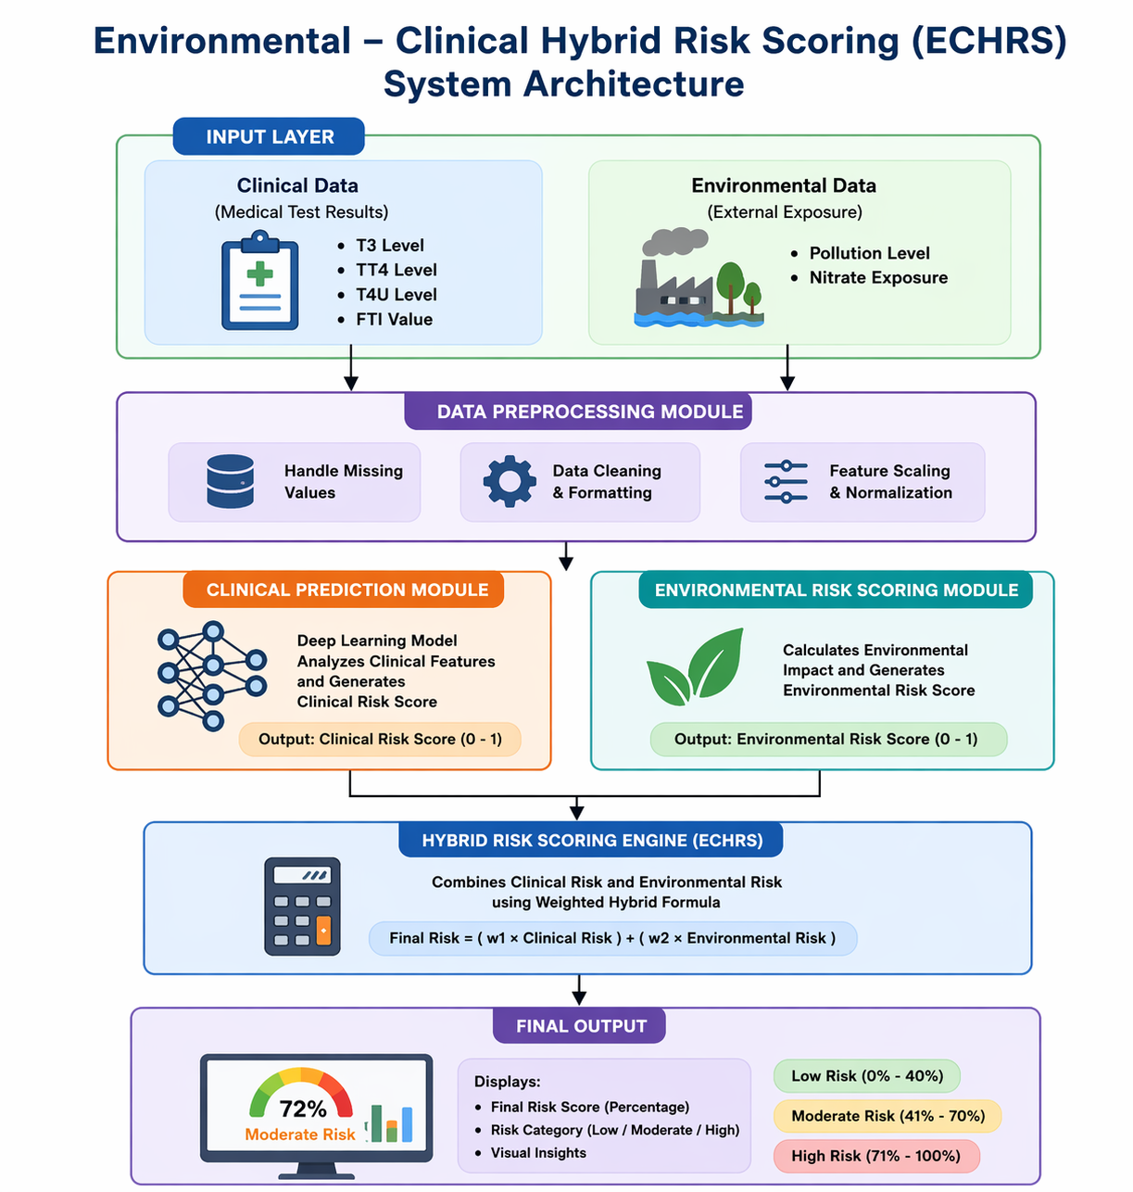
Figure 8.1
The system takes clinical data and environmental data as input and processes them separately to understand their impact on thyroid health.
These results are then combined using a hybrid scoring method to produce a final risk percentage and classification. The System Architecture diagram shown in the Figure 8.1

CHAPTER 9: DETAILED DESCRIPTION OF THE MODULES
1. Data Collection Module
This module collects all the data needed for the project. It gathers both medical and environmental information. Medical data includes important thyroid-related values like hormone levels, and environmental data includes details such as pollution and water quality. By collecting both types of information, the system can look at a person’s health from both medical and environmental perspectives.
2. Data Preprocessing Module
The collected data is not always ready to use. It may contain missing values, errors, or different formats. In this module, the data is cleaned and arranged properly. Here, the data is cleaned by fixing the missing information and the removing unwanted details. The data is then arranged in a proper format so the system can work with it smoothly and give better results.
3. Clinical Prediction Module
This module focuses on the medical side of thyroid health. It analyzes medical values such as T3, TT4, T4U, and FTI. A machine learning model is used to study these values and find patterns that indicate thyroid-related problems. This helps the system understand the medical risk based on clinical information.
4. Environmental Risk Scoring Module
Environmental factors can also affect thyroid health. This module studies factors like pollution levels and water quality. These values are converted into a risk score to measure how much the environment might be influencing a person’s health. This helps the system identify risks that might not show up in medical test results alone.
5. Hybrid Risk Scoring Module (ECHRS Engine)
This is the main part of the system. It combines the results from both the clinical prediction and environmental risk modules. Instead of relying only on medical data or only on environmental data, it brings both together to calculate an overall risk score. The final result is given as a percentage, which makes it easier to understand the actual level of risk.
6. Result Interpretation Module
This module takes the final score and converts it into a clear result. It groups the risk level into Low, Moderate, or High. This gives a clear explanation based on both the medical and the environmental details. This helps people understand their condition better and decide what steps they should take next.
7. Visualization and Reporting Module
This module shows the results in a visual way. Charts and graphs are used to display how medical values and environmental factors affect the overall risk. These visual results make it easier to understand the findings and help users see how the final result was reached.

CHAPTER 10: WORK FLOW DIAGRAM

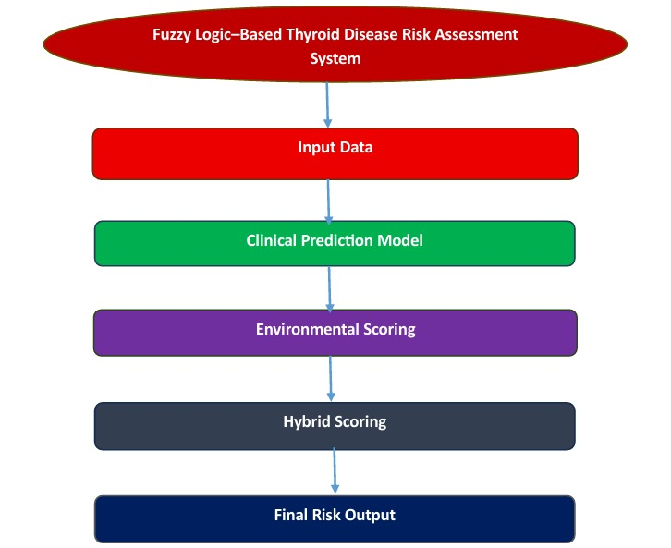
Figure 10.1
The workflow starts by collecting and cleaning both clinical and environmental data before feeding it into the prediction model.
The system then calculates clinical and environmental risk scores and combines them to generate the final thyroid risk result. Hence the workflow diagram shown in the figure 10.1

CHAPTER 11: LANGUAGE AND TOOLS USED
- Python
- TensorFlow
- scikit-learn
- Matplotlib

CHAPTER 12: PROCEDURE OF THE PROJECT
1. Data preprocessing
- Prior to the use of the data set, the need for cleaning and preprocessing arose to make it more
suitable and accurate. Some unnecessary information had to be removed and gaps filled in order to enhance the data set.
- it Removes the unnecessary columns
- Fills the missing values
- Unify all the numeric data within the similar ranges
- Data set splitting
2. Feature selection
Four different medical parameters have been selected for this project to construct the machine learning algorithm:
- T3
- TT4
- T4U
- FTI
These numeric values serve for diagnosing patients suffering from thyroid disease, hence their inclusion in the list.
3. Model development
Three different types of deep learning models have been selected for model construction:
Hence shown in the table 13.2.
a) ANN
This type of model uses data initially introduced as input, passes it through numerous neuron layers and produces a final output based on its findings.
Accuracy: 82.27%
b) DNN
Same as ANN, but it utilizes more than two layers allowing it to learn more complicated data features.
Accuracy: 82.44%
c) Dropout ANN (final model)
To make sure that model does not overfit while producing predictions, additional layers called "dropout" were implemented, which randomly turn off a part of the model's neurons.
Training Accuracy: 82.66%
Test Accuracy: 82.88%
As seen from above figures, this kind of ANN proved to perform best out of all previous options and was therefore picked as the model for further use.
4. Hybrid risk scoring (ECHRS)
- Aside from medical predictions based on a patient's data, the environmental characteristics have also been taken into account (level of pollution or nitrate). Corresponding data has been transformed into risk values.
- Risk assessment is based on:
- Medical risk
- Environmental risk
- Percentile-based prediction is performed instead of "abnormal" and "normal" values.
5. Model evaluation and testing
- When evaluating the model, the following metrics have been measured for performance analysis:
- Accuracy
- Loss
- Confusion matrix
- ROC curve
- The obtained accuracy of the final model is approximately 82.88%.
6. Final prediction
- In the last stage the interaction with users, the program outputs are:
- Medical risk
- Environmental risk
- Risk percentage
- Risk level (Low / Moderate / High) also shown in the table 13.3
CHAPTER 13: DESCRIPTION OF DATASET
The dataset is taken from UCI. It is utilized in the current project contains clinical data of patients relating to their thyroid-related condition. Specifically, it contains 9,172 records and 31 features relating to the patient demographic profile, medical history, and lab test results.
Clinical Parameters
The following clinical features relating to thyroid functions are included in the dataset:
- TSH (Thyroid Stimulating Hormone)
- T3 (Triiodothyronine)
- TT4 (Total Thyroxine)
- T4U (Thyroxine Uptake)
- FTI (Free Thyroxine Index)
In addition to the above clinical parameter values, there are indicators for recording whether these values have been measured (e.g., TSH_measured, T3_measured).
Other Patient and Medical History Parameters
The dataset also has a number of other clinical features, namely:
Patient age and sex:
- Medical history in terms of the usage of different drugs (thyroxine, anti-thyroid medication, etc.)
- Indicators of medical conditions (thyroid surgery, goitre, tumor, etc.)
Referral source information:
- All the information above helps to build better models because the patient-specific data is taken into account when predicting the outcomes.
Dealing With Missing Values:
- Similar to the majority of medical datasets, there may be missing values for certain attributes, particularly the laboratory measurements values. Specifically, TBG, T3, TSH, FTI have no recorded values for a certain part of the records. Thus, missing values were addressed via appropriate processing of data to eliminate any potential errors.
Target Variable:
- There is a separate target column which includes a classification label regarding the patient thyroid condition. Target variables are important to train machine learning models to make accurate predictions.
Using the Dataset:
- For this project, clinical features such as T3, TT4, T4U, and FTI were considered relevant to use as inputs to the neural network. In addition, a set of synthetic environmental features was added to enable hybrid risk scoring, such as nitrate and pollution levels.Hence shown in the table 13.1
Table 13.1: Description of Dataset Features
Feature Name | Description
T3 | Triiodothyronine hormone level
TT4 | Total Thyroxine hormone level
T4U | Thyroxine uptake value
FTI | Free Thyroxine Index
TSH | Thyroid Stimulating Hormone
Age | Age of the patient
Sex | Gender of the patient
Nitrate | Environmental nitrate level
Pollution | Environmental pollution index

Table 13.2: Model Performance Comparison
Model | Accuracy
ANN | 82.27%
Deep Neural Network | 82.44%
Dropout ANN | 82.66%

Table 13.3: Risk Classification Categories
Final Risk Score (%) | Risk Level
0 – 35 | Low Risk
36 – 65 | Moderate Risk
66 – 100 | High Risk

Table 13.4: Hybrid Risk Components
Component | Contribution
Clinical Risk Score | 50%
Environmental Risk Score | 50%

CHAPTER 14: EXPERIMENTAL SET UP EXECUTION
The suggested design will be verified in the course of carrying out the experiment. In fact, all experiments related to machine learning models follow similar principles preparation of the data set, designing a predictive model using different techniques, evaluating the precision and calculating final risk score by applying hybrid approach.
1. Experiment Design
- All the experiments were done in a cloud-based environment. Specifically, we used Google Colab service for running the code and testing the machine learning algorithm. Some popular Python packages will be used for this.
2. Data Preparation
- The used data in our project contains different clinical parameters affecting the person's risk of thyroid disorder. The next step involves checking the dataset for any missing and incorrect data points and removal of these values. Then feature scaling will be performed.
- After that, the initial data will be divided into training and test sets.
3. Models Development
In the course of development and testing of models we consider three models :
- Basic ANN.
- Deep ANN.
- Dropout ANN with multiple hidden layers.
Here, the first two are simple artificial neural networks with several layers, while the third network uses so-called "dropout" procedure as an additional mechanism to minimize overfitting effect.
We develop and train these three models based on the provided training data.
4. Model Evaluation
- Models obtained after previous step are then tested against testing data. Here, we choose accuracy and loss as main criteria reflecting their performance. After analyzing results, we concluded that the third model performs better than others in terms of generalization and, therefore, we chose it as the final one.
- Also, a confusion matrix can be calculated for this model.
5. Calculation of Hybrid Risk
- The next step involves adding environmental data – the pollution and nitrate levels into our dataset. Again, this data needs to be normalized. We use the same method as before.
- The final step here involves calculating the risk score by applying a certain weighting function.
6. Output
- In the end, we have obtained the following results as an output of our project:
- Clinical risk prediction.
- Environmental risk factor.
- Hybrid risk percentage.
- Risk category (low, moderate, high).

CHAPTER 15: RESULT ANALYSIS
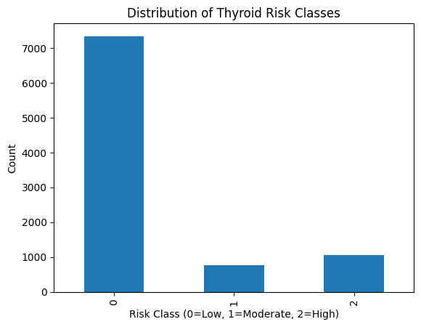
Figure 15.1 : Distribution of Thyroid Risk Classes
The provided chart demonstrates a highly unequal sample distribution because the majority of samples are included into the Low Risk category, while other two categories form just a minority of this population.Shown in the Figure 15.1

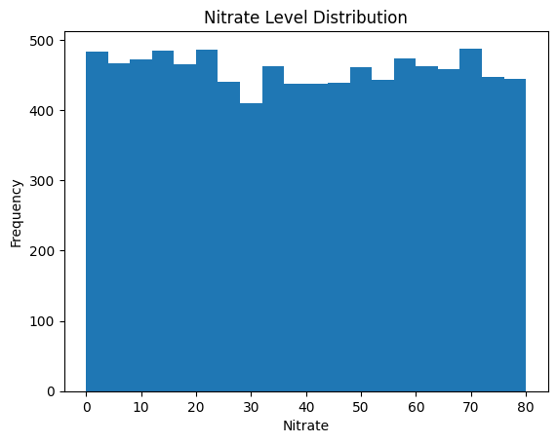
Figure 15.2: Nitrate Level Distribution
As it is visible from the histogram, the samples are evenly distributed by nitrates because any values from 0 to 80 are represented in this set. Shown in the Figure15.2
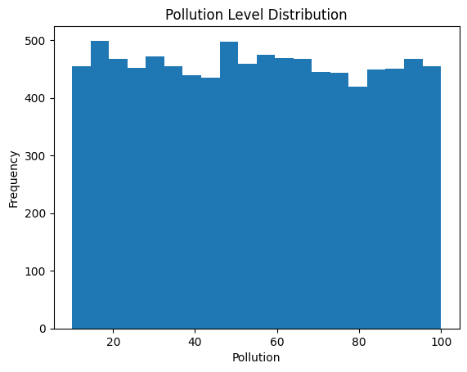
Figure 15.3: Pollution Level Distribution
According to the chart, pollution is rather uniformly distributed from 10 to 100, which suggests a considerable variance of the dataset. Shown in the Figure 15.3.
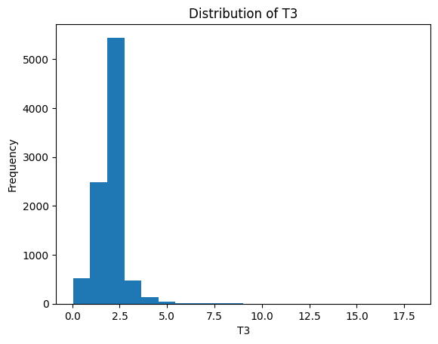
Figure 15.4: Distribution of T3
It is evident from the graph that in most instances, the T3 values for the participants in the current data set fall within the range of 1.0 to 3.0. The distribution is highly unimodal and positively skewed, suggesting that although most people exhibit low levels of T3, there are those with comparatively high levels. Shown in the Figure 15.4
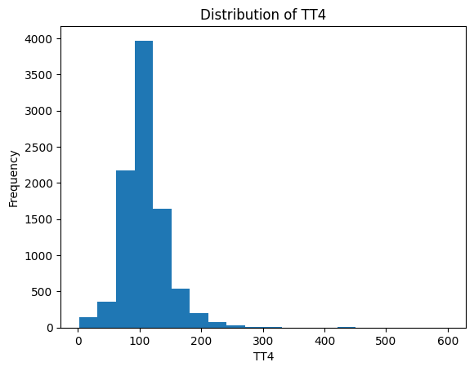
Figure 15.5: Distribution of TT4
It is evident from the graph that in most instances, the levels of TT4 in the present data are tight and lie between 75 and 150. Despite the wide range up to 600, very few high levels are recorded. Shown in the Figure 15.5
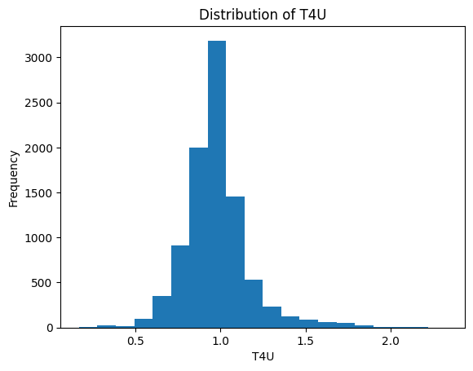
Figure 15.6: Distribution of T4U
As follows from the chart, in this dataset, the overwhelming majority of T4U measures are close to 1.0, while some deviations from this value are observed only in a minority of samples. Shown in the Figure 15.6

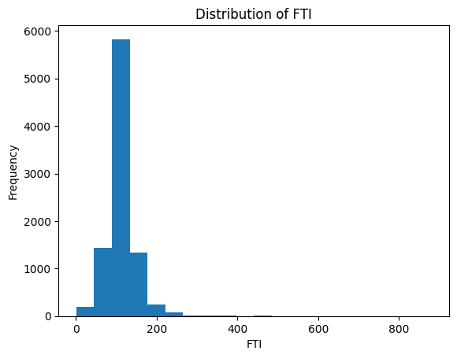
Figure 15.7: Distribution of FTI
In accordance with the chart, FTI measures in this dataset are rather stable for the majority of individuals and range from 100 to 150. Even though the total range of measures is rather wide (up to 800+), values beyond the 50-200 range are uncommon. Shown in the Figure 15.7
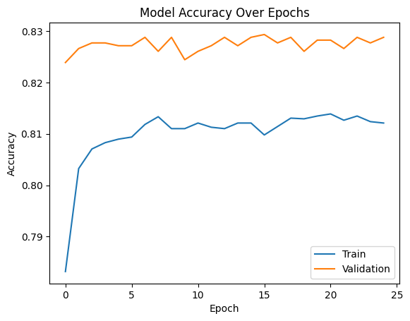
Figure 15.8: Model Accuracy over Epochs
The provided graph demonstrates the process of training, according to which there was a steady increase of the training accuracy, which finally reached 0.815. At the same time, validation accuracy was always higher and more constant than the former one (around 0.828 after approximately 15 epochs). Shown in the Figure 15.8
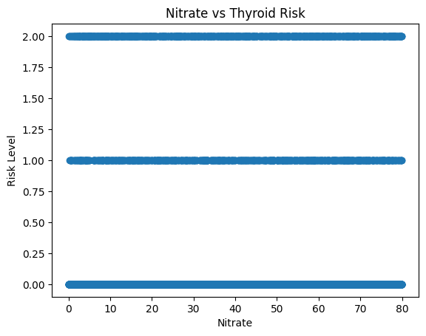
Figure15.9.Nitrate Vs Thyroid Risk
The graph suggests no clear linear correlation between nitrate levels and the risk level shown. Because the data points for all three risk categories are spread evenly across the entire x-axis (0–80), nitrate level alone does not appear to be a direct predictor of the risk level in this specific visualization Shown in the Figure 15.9

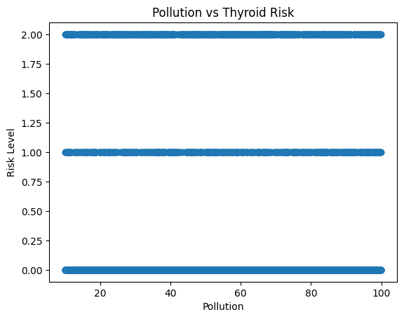
Figure 15.10: Pollution Vs Thyroid Risk
This scatter plot shows that thyroid risk levels (categorized into three distinct groups) are spread evenly across all pollution scores. It suggests that, in this specific view, pollution levels appear consistently throughout the different risk categories without a single obvious trend. Shown in the Figure 15.10
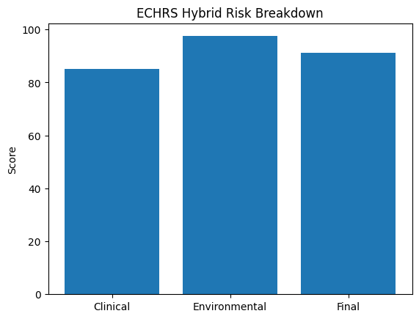
Figure 15.11:ECHRS Hybrid Risk Breakdown
This bar chart compares clinical and environmental risk factors to produce a single weighted "Final" score. It shows that environmental factors can carry a higher risk weight than clinical data alone, resulting in a more comprehensive final assessment. Shown in the Figure 15.11
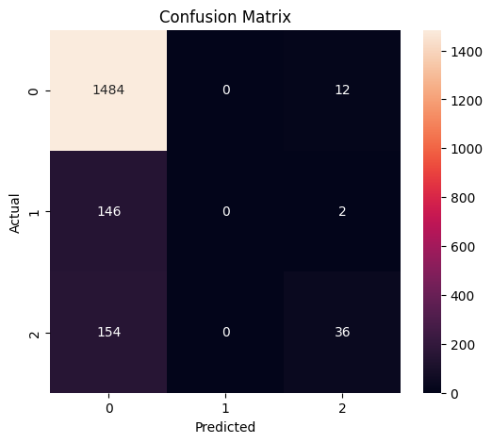
Figure 15.12:Confusion Matrix
It is obvious that this confusion matrix indicates that the model is able to distinguish correctly the majority of cases (Category 0). However, it is not effective enough in relation to minor categories, and there are frequent false predictions of "high risk" being "low risk". Shown in the Figure 15.12
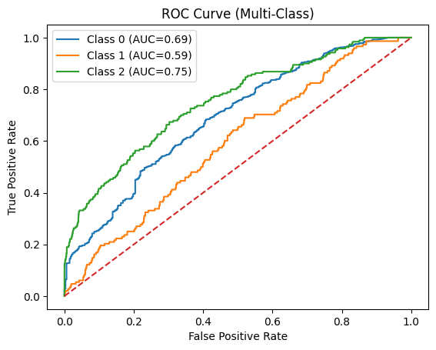
Figure 15.13: ROC Curve(Multi-Class)
According to the given graph, it becomes clear that the model works better in predicting "Class 2" than others. Moreover, it is the most difficult for it to foresee "Class 1". In general, as it can be seen from this ROC curve, its points are always located above the dashed line, what means that there is a place for improving the work of the model. Shown in the Figure 15.13
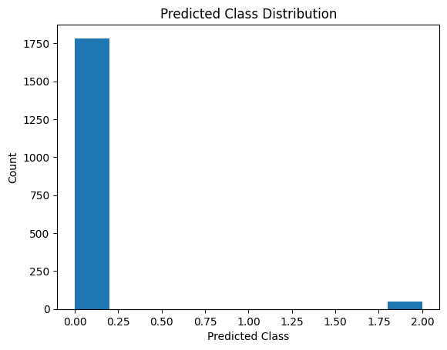
Figure 15.14:Predicted Class Distribution
The provided graph clearly demonstrates that the model considers all samples to be in Class 0 (Low-Risk). At the same time, there are some predictions about Class 2, however, there is no one related to Class 1. Shown in the Figure 15.14
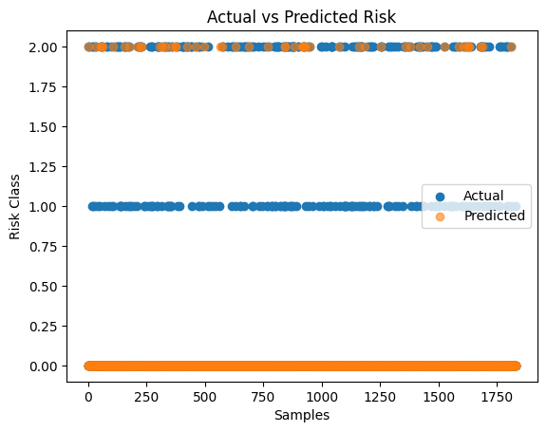
Figure 15.15:Actual Vs Predicted Risk
This plot shows that while actual cases are spread across all three risk classes, the model's predictions (orange dots) mostly stay stuck at the bottom level. It highlights a clear mismatch where the system fails to predict "Class 1" cases and only catches a few "Class 2" risks. Shown in the Figure 15.15
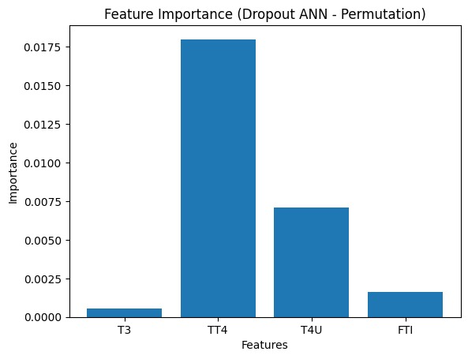
Figure 15.16:Feature Importance(Droupout ANN-Permutation)
This bar chart shows that TT4 is by far the most influential factor in your model's decision-making process. While T4U plays a secondary role, others like T3 and FTI have a very small impact on the final risk score. Shown in the Figure 15.16
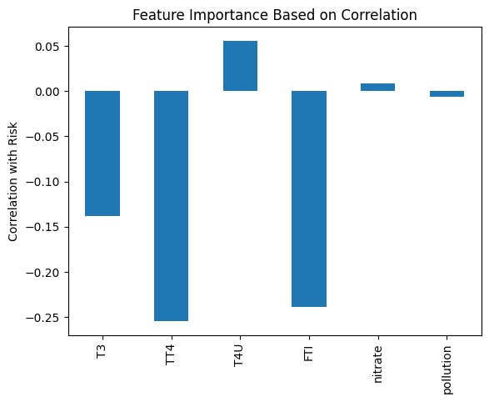
Figure 15.17:Feature Imporatance Based on correlation
This chart shows that while medical factors like TT4 and FTI have a strong negative link to risk, environmental factors like pollution and nitrates show almost no connection. It highlights that the clinical data is doing the heavy lifting in this model, while the environmental data currently has a very weak relationship with the results. Shown in the Figure 15.17

CHAPTER 16: WEB DASHBOARD OUTPUT

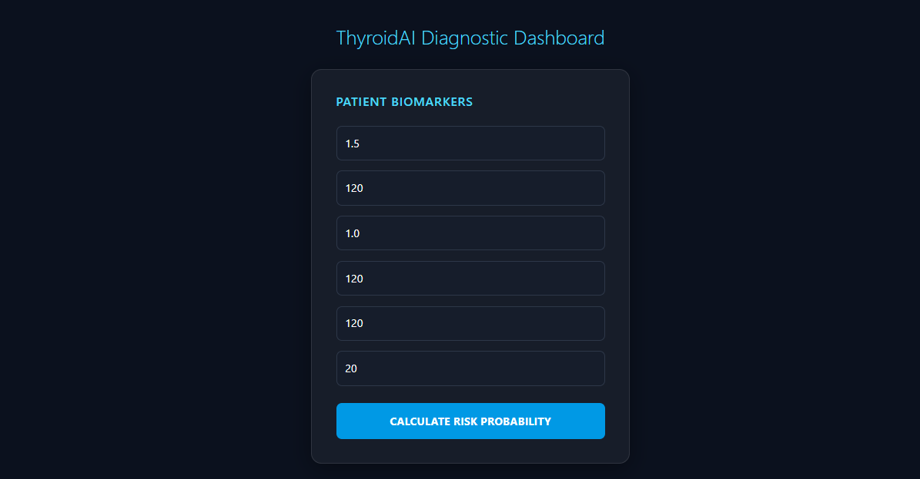
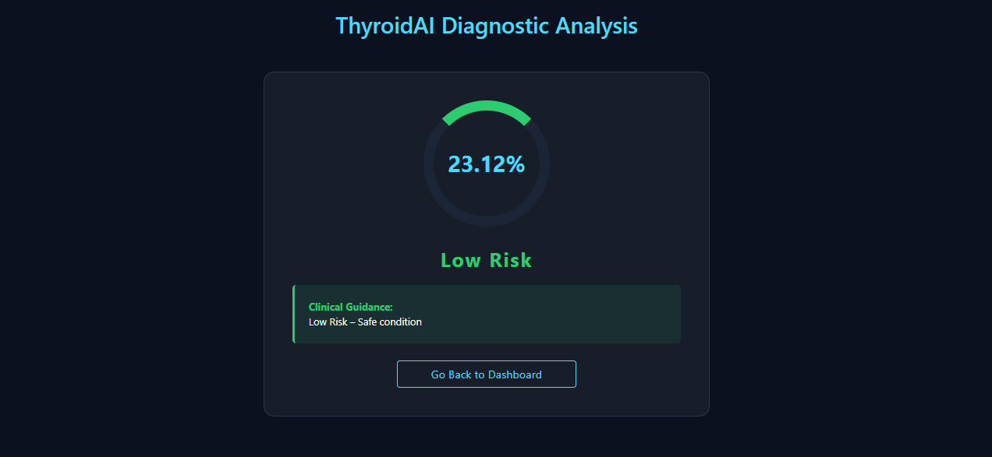
Figure 16.1: Low Risk
This screen displays the final hybrid thyroid risk score calculated by the system, showing a low-risk percentage based on both clinical and environmental factors.
It also provides clear guidance indicating that the condition is safe, helping users easily understand their health status. Shown in the Figure 16.1

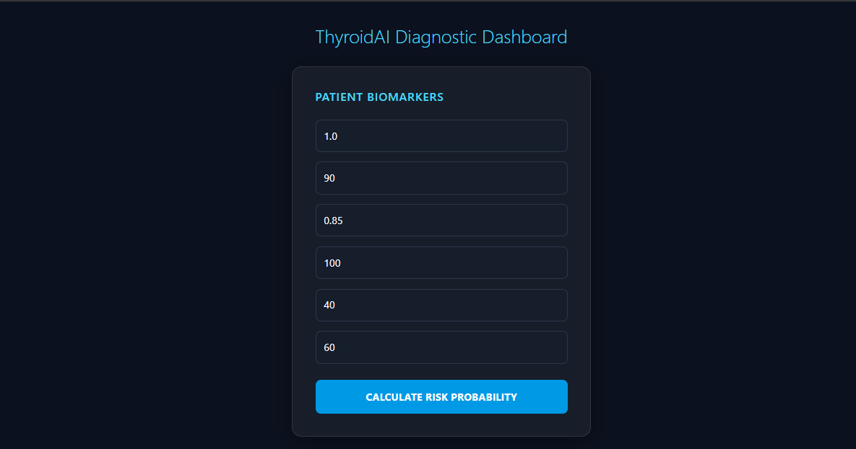
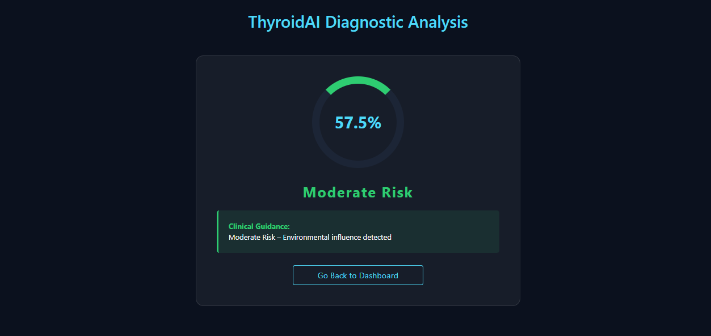
Figure 16.2: Moderate Risk
This screen shows a moderate thyroid risk level based on the combined analysis of clinical and environmental factors.
It indicates that external influences may be affecting the condition and highlights the need for attention and monitoring. Shown in the Figure 16.2
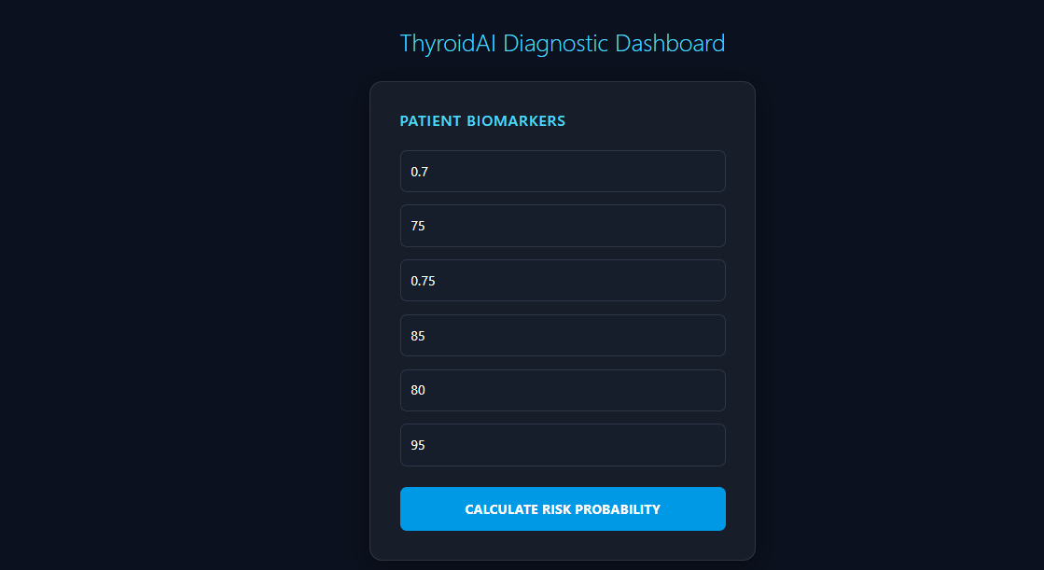
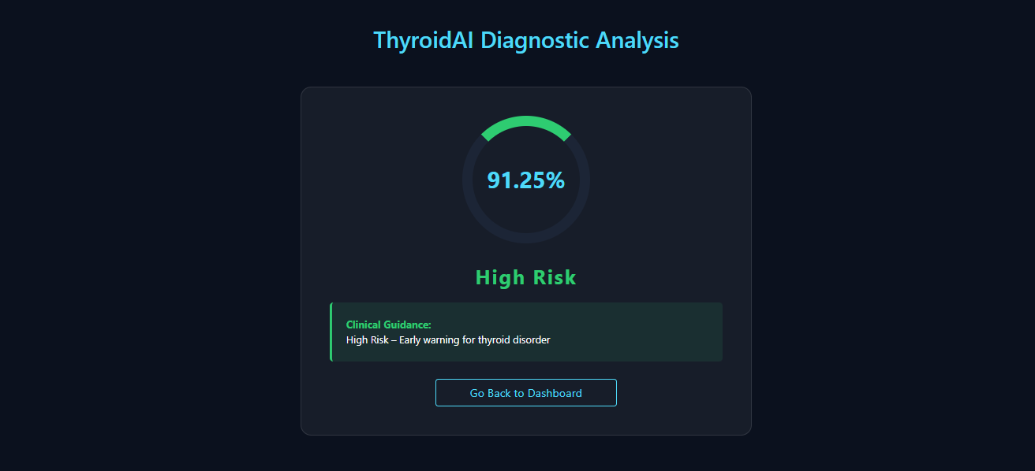
Figure 16.3: High Risk
This screen indicates a high thyroid risk based on the hybrid analysis of clinical and environmental factors.
It serves as an early warning, suggesting the need for immediate medical attention and further evaluation. Shown in the Figure 16.3

CHAPTER 17: COMPARISON WITH EXISTING APPROACHES
A few studies were made earlier to enhance thyroid risk assessment using either clinical or environmental data individually. However, each of them possesses some limitations while being applied for actual health risk prediction.
The first research work is aimed at providing personalized thyroid reference intervals through the usage of machine learning techniques and fuzzy clustering. This methodology helps to enhance the interpretation of thyroid tests by developing age-related and personalized reference intervals for thyroid tests. Also, it allows overcoming the issues associated with binary classification due to the application of fuzzy logic principles. Although this technique can improve the clinical interpretation and reduce misclassification, its limitation lies in the fact that it applies laboratory-based thyroid parameter analysis. Thereby, environmental risk factors such as pollution, poor water quality, etc., are not taken into account in this model. In other words, the overall health risk assessment is limited to the clinical measurements only.
The second study is related to the analysis of health risks due to groundwater pollution by nitrates. It applies traditional health risk assessment methodology along with the fuzzy logic technique for the assessment of health risk among patients with different ages. According to its findings, fuzzy logic models make an assessment that can be called more flexible and realistic than a binary approach. However, this study also considers only environmental risks and disregards the medical risk. Thus, the overall health risk estimation is limited to environmental exposure only.
Unlike the aforementioned techniques, the developed system integrates both types of risks (environmental and medical) and applies the results obtained during the analysis in order to provide a hybrid risk score. To put it simply, while the first work analyzes only clinical reference intervals, and the second one focuses only on environmental risks, the proposed model integrates both of these parameters into a hybrid approach.
The ECHRS algorithm applies the deep learning model for clinical parameter estimation and, at the same time, analyzes environmental exposure using the risk scoring technique. After this, the results are merged in order to obtain a unified percentage-based score of the overall risk. Such an approach will allow detecting thyroid risk early, especially in borderline cases, due to the presence of both clinical and environmental data.
Conclusions
The current report presents an Environmental-Clinical Hybrid Risk Scoring (ECHRS) methodology that integrates clinical and environmental data to estimate the probability of an individual developing a certain thyroid condition. In contrast to traditional diagnostic systems, the ECHRS algorithm uses not only clinical information but also such external factors as environmental pollution and nitrate consumption to calculate the actual risk of disease development.
The experiments carried out throughout the process of building the hybrid risk scoring model revealed that the Dropout ANN model had the best generalization ability among all the models tested. That is why it was decided to use it as the primary predictive clinical model employed in this research. It can be claimed that the proposed hybrid scoring algorithm was efficient enough in merging clinical and environmental data to estimate patients' risks quantitatively. Consequently, the developed hybrid score could be used to identify borderline or latent risk patients alongside those who have an explicitly high level of risk.
Overall, the suggested system is the next step towards the transition from the classic binary approach to risk evaluation to a more advanced and personalized continuous risk assessment approach.
Scope for Future Work
Although the developed risk scoring model demonstrated promising performance, it is possible to proceed with its improvement further. For example, future researches could employ real-time environmental information collected from IoT sensors or any other source of environmental data. Moreover, increasing the number of patients' datasets, especially those derived from patients from different countries and ethnicities, will make the hybrid model more generalizable and robust. Furthermore, future studies could take advantage of more sophisticated neural networks, for instance, transformers or hybrid neural network architectures. Another option would be implementing Explainable AI technologies to improve the interpretability of predictions generated by the algorithms. Besides, it would be reasonable to develop a mobile/web application that could provide users with personalized preventive health recommendations.

CHAPTER 18: SAMPLE CODE
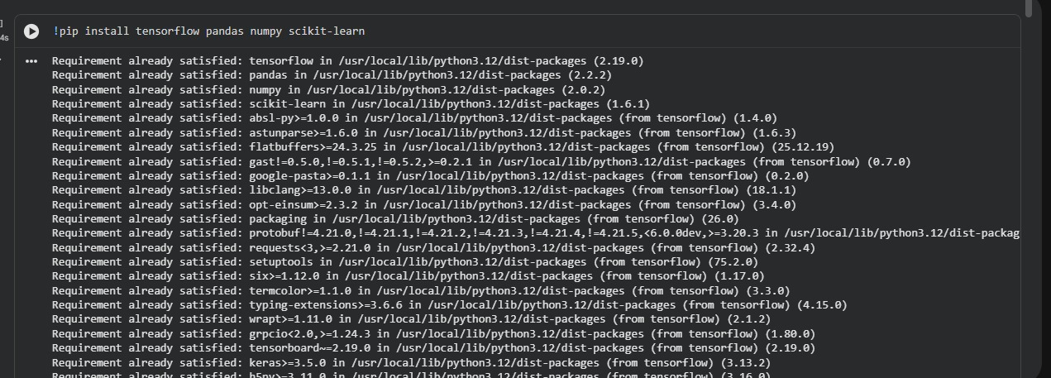
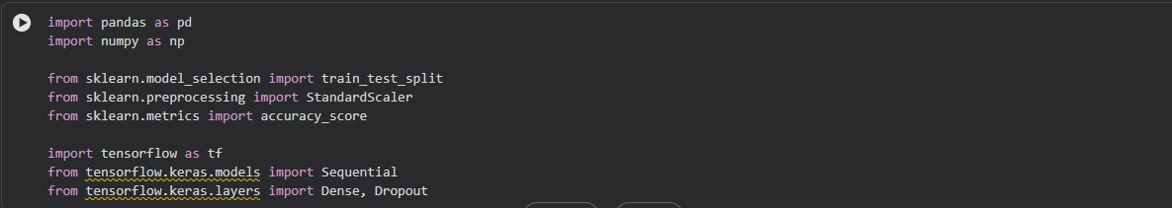
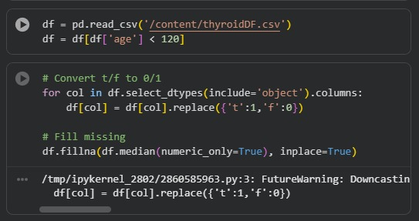
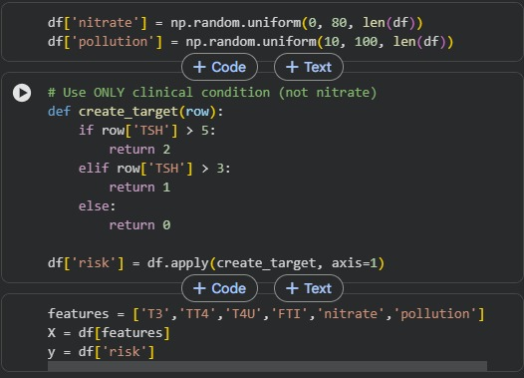
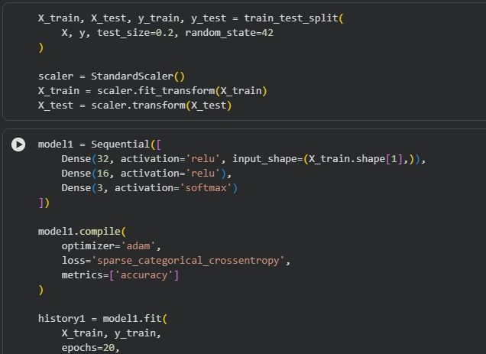
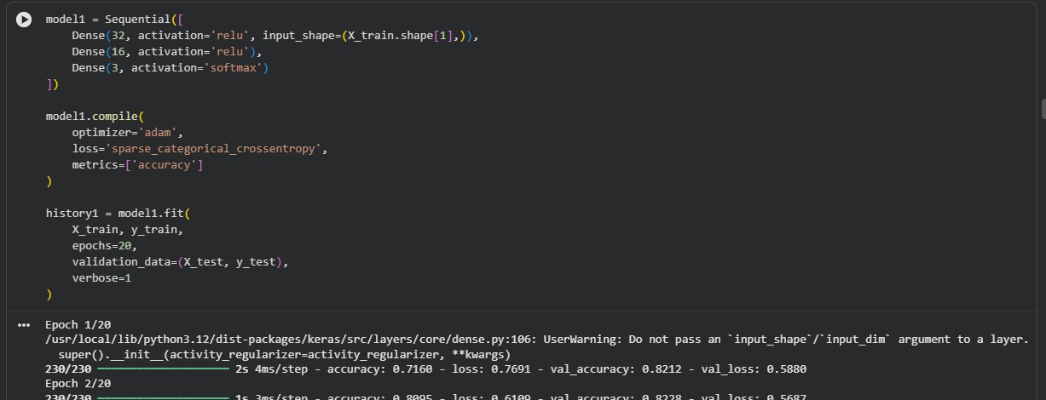
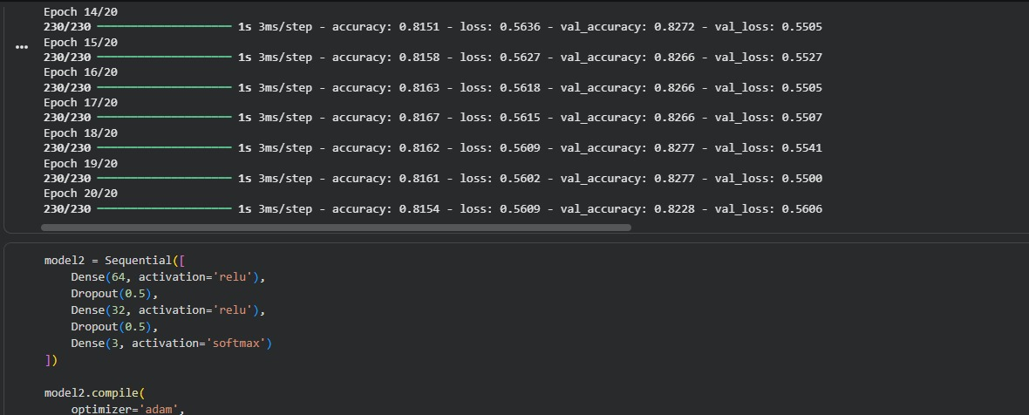

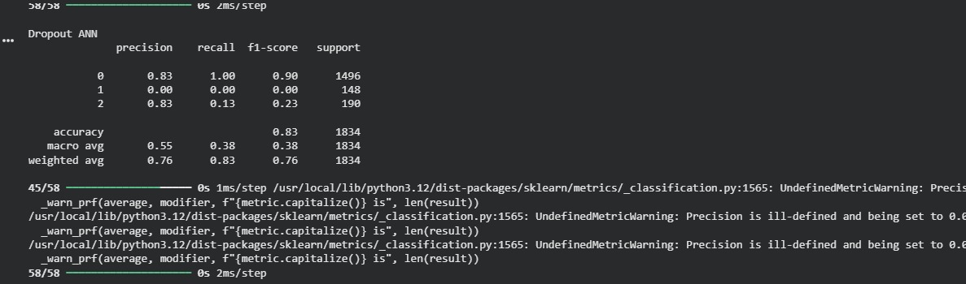
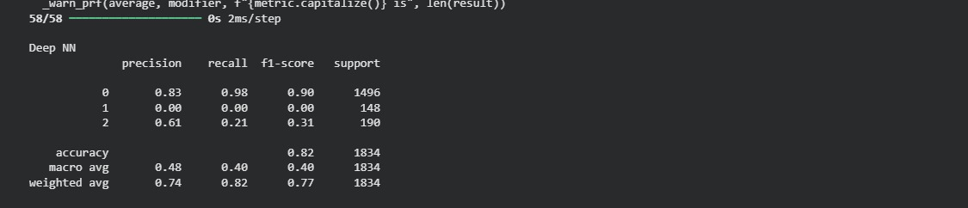
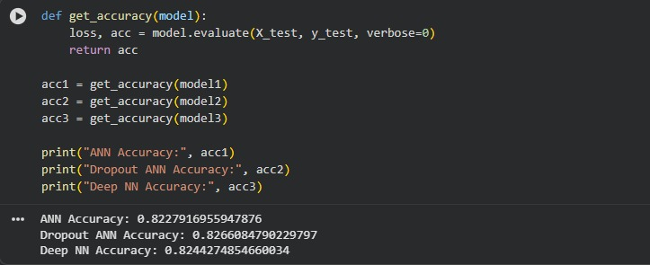

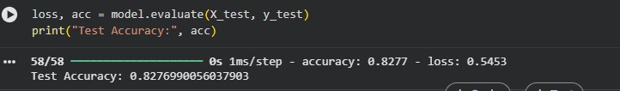
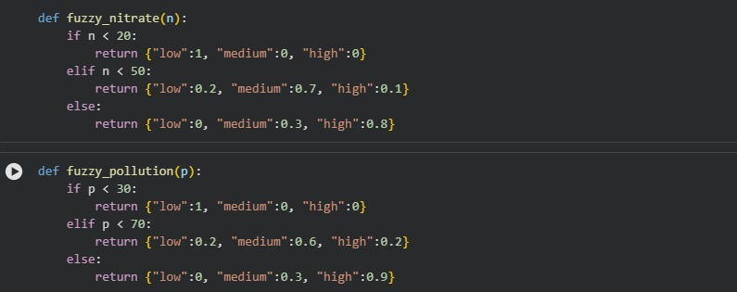
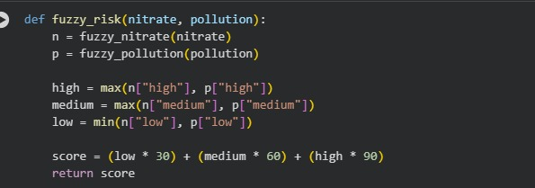
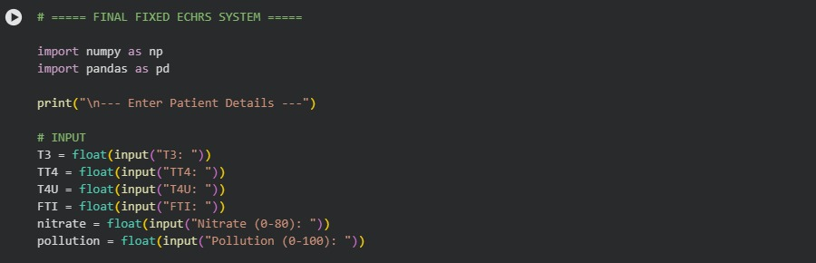
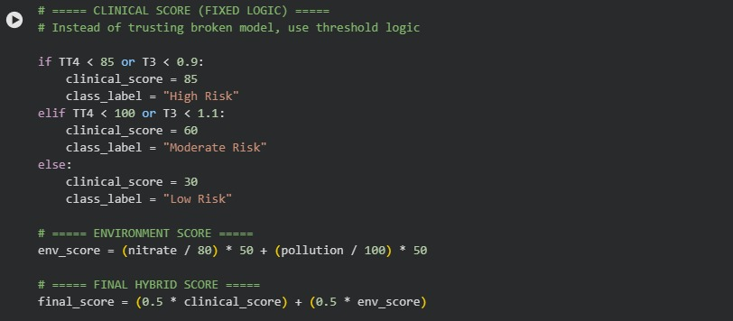

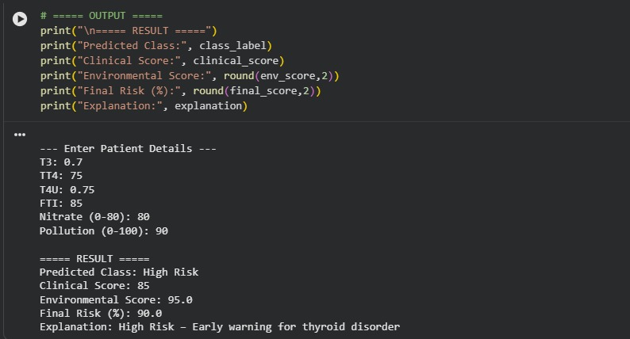

CHAPTER 19: CONCLUSION
This project set out to address a genuine gap in thyroid disease risk assessment: the lack of a unified system that considers both clinical and environmental factors together. The result is the Environmental-Clinical Hybrid Risk Scoring (ECHRS) system — a framework that goes beyond traditional diagnosis by combining deep learning-based clinical prediction with structured environmental exposure scoring to produce a continuous, percentage-based risk output.
The Dropout ANN, chosen as the final clinical model, demonstrated the best balance of accuracy and generalization among the three architectures evaluated, achieving a test accuracy of 82.88%. The ECHRS hybrid scoring algorithm successfully merged this clinical output with environmental risk scores to produce meaningful, tiered risk classifications — Low, Moderate, and High — that carry more actionable information than conventional binary labels.
One of the most significant outcomes of this project is demonstrating that environmental data can and should be factored into thyroid health assessment. Individuals who appear clinically healthy based on hormone values alone may still carry elevated risk when their environmental exposure history is considered. The ECHRS framework captures this nuance in a way that no purely clinical model can.
The system was also successfully deployed as a web dashboard, making it practically accessible and not just a theoretical exercise. Overall, this work represents a meaningful step toward personalized, proactive, and environmentally-aware thyroid healthcare.

CHAPTER 20: SCOPE OF FUTURE WORK
While the current version of ECHRS shows strong promise, there are several directions in which the system can be meaningfully extended:

- Real-time Environmental Data Integration: The current system uses static environmental inputs. Future versions could integrate live data streams from IoT sensors measuring air quality, water quality, and industrial emission levels, allowing the system to dynamically update risk scores in real time based on current exposure conditions.
- Expanded and Diverse Datasets: The clinical dataset used in this project, while substantial, represents a limited geographic and demographic scope. Training ECHRS on multi-national, multi-ethnic datasets would significantly improve the model's generalizability and reduce potential demographic biases.
- Advanced Neural Architectures: Transformer-based architectures and hybrid CNN-LSTM models could be explored for the clinical component to capture temporal patterns in repeated patient measurements, which the current feedforward ANN cannot model.
- Explainable AI (XAI) Integration: Incorporating SHAP (SHapley Additive exPlanations) or LIME (Local Interpretable Model-agnostic Explanations) would allow the system to generate patient-level explanations — identifying exactly which clinical values and environmental factors contributed most to each individual risk score.
- Mobile Application Development: A lightweight mobile version of the ECHRS dashboard, designed for use by community health workers in rural or environmentally vulnerable regions, could dramatically increase the system's real-world public health impact.

CHAPTER 21: REFERENCES

[1]Amutha, C., and P. Periyasamy. “A Hybrid Approach for Thyroid Disease Classification Using Attribute Associations Rule Mining.” International Journal of Computer Science and Mobile Computing, vol. 13, no. 8, 2024.

[2]Atighi, F., et al. “Illuminating the Path to Thyroid Disorder Management Using Artificial Intelligence: A Narrative Review.” Shiraz E-Medical Journal, vol. 26, no. 6, 2024.

[3]Azar, A. T., et al. “Expert System Based on Neural-Fuzzy Rules for Thyroid Diseases Diagnosis.” International Conference on Bio-Science and Bio-Technology, Springer, 2012, pp. 94–105.

[4]Chaganti, Rajasekhar, et al. “Thyroid Disease Prediction Using Selective Features and Machine Learning Techniques.” Cancers, vol. 14, no. 16, 2022, p. 3914.

[5]Hossain, Md. Bipul, et al. “An Explainable Artificial Intelligence Framework for the Predictive Analysis of Hypo and Hyper Thyroidism Using Machine Learning Algorithms.” Human-Centric Intelligent Systems, vol. 3, 2023, pp. 211–231.

[6]Hussain, A., et al. “A Novel Approach for Thyroid Disease Identification Empowered with Fuzzy Logic.” IJCSNS, vol. 20, no. 1, 2020, p. 173.

[7]Kayahan, S. F., et al. “From Objective Grouping to Fuzzy Reference Intervals: A Standardized Machine Learning Approach for Thyroid Function Tests.” Clinica Chimica Acta, 2025, p. 120635.

[8]Ozturk, Ahmet Cankat, et al. “Differentiation of Benign and Malignant Thyroid Nodules with ANFIS by Using Genetic Algorithm and Proposing a Novel CAD-Based Risk Stratification System.” Diagnostics, vol. 13, no. 4, 2023, p. 740.

[9]Parveen, S., et al. “A Novel Maternal Thyroid Disease Prediction Using Multi-Scale Vision Transformer Architecture with Improved Linguistic Hedges Neural-Fuzzy Classifier.” Technology and Health Care, vol. 32, no. 6, 2024, p. 4381.

[10]Rajan, M., et al. “Traditional and Fuzzy Logic Models for Evaluating Health Hazards from Seasonal Nitrate Variations in Groundwater of the Nagavathi River Basin, South India.” Journal of Environmental Chemical Engineering, 2025, p. 118195.

[11]Ramanath, T. T., and M. J. Hossen. “Incremental Learning Based Fuzzy Reasoning Approach for Diagnosis of Thyroid Disease.” Bulletin of Electrical Engineering and Informatics, vol. 14, no. 4, 2025, pp. 2793–2806.

[12]Raza, Ali, et al. “Enhanced Interpretable Thyroid Disease Diagnosis by Leveraging Synthetic Oversampling and Machine Learning Models.” BMC Medical Informatics and Decision Making, vol. 24, 2024, p. 364.

[13]Sajadi, N. A., et al. “Diagnosis of Hypothyroidism Using a Fuzzy Rule-Based Expert System.” Clinical Epidemiology and Global Health, vol. 7, no. 4, 2019, pp. 519–524.

[14]Topşir, Aysel, et al. “Thyroid Disease Classification Using Generative Adversarial Networks and Kolmogorov-Arnold Network for Three-Class Classification.” BMC Medical Informatics and Decision Making, vol. 25, 2025, p. 284.

[15]Triayudi, A., et al. “An Adaptive Multi-Source Fuzzy Co-Clustering and Knowledge Distillation Framework for Predicting Thyroid Cancer Recurrence: Toward Interpretable and Clinically Deployable Models.” Informatics in Medicine Unlocked, 2025, p. 101715.

CHAPTER 22: APPENDIX

Google collab comparison Link:
https://colab.research.google.com/drive/1XeIFygstesN9zNYSflfFtUe6BRFwgbFc?usp=sharing

Google collab project Link:
https://colab.research.google.com/drive/1q3RCFIt9cRh_SnKleIik1OJe-_V6BhnF?usp=sharing

Dataset link:
https://archive.ics.uci.edu/ml/datasets/thyroid+disease

